

CEG 4136 Computer Architecture III: FINAL EXAM

Duration: 3 hours | Professor: Dr. M. Bolic
Total Points = 100 | Session: Fall 2013
Note: Closed book exam. Calculators are allowed.

Name: _______________________Student ID:_______________

Question | Maximum | Score
1 | 30
2 | 15
3 | 15
4 | 25
5 | 15
Total | 100

Question 1 (30)
Interconnection networks
- Explain why virtual buffers are not fully utilized when dateline approach is used for deadlock prevention.

- What is the diameter, degree and bisection width of 4x6 torus network with bidirectional traffic?

- If reducing the amount of memories and buffers in a system-on-a-chip is a main design goal, which switching technique would you use:
  - circuit switching
  - virtual cut through
  - wormhole
- Which of the following flow control strategies use buffer to store a packet being denied the channel?
- Blocking flow control
- Virtual cut-through routing
- Detour after being blocked

- How does one node in the message passing network know that the next node has the flit buffer full?

- Consider a network with 8Gbits/sec bandwidth per channel. The delay of a single router is 8ns. The packet length is 256 bytes and the message travels between the source and the destination through 4 routers. What is the latency of this message if we use wormhole routing?

Question 2 (15)
Caches and Synchronization
- The presence vectors shown below correspond to the full directory entries for some cache block using full-map directory protocol. Describe each step that happens in case of a write miss by cache 0.

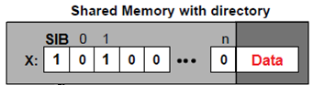

- Assume all 16 processors in a bus-based machine try to acquire test&set lock simultaneously (and only once each). How many bus transactions will it take until all processors have acquired the lock if all critical sections are empty (each processor simply does LOCK and UNLOCK with nothing in between).

Question 3 (15)
Multicore
Multicore chip is shown in figure below:
- What kind of network topology is this?

- Show an example of tile organization in details assuming shared L2 cache with distributed directories.

- Eight cores on the left side are selected to run VM with the operating system 1 while another 8 cores are running VM with the operating system 2. If the packet is sent from the left part of the chip to the right part (it crosses the boundaries of two VMs), does the hypervisor need to take a control of that communication event? How can that be done?

Question 4 (30)
Cache coherence
Let us consider a system with 2 processors that use write-back private caches and a shared memory all connected to a bus. Each cache has four blocks label 0, 1, 2 and 3. The system uses MSI protocol.
Assume that the same clock drives the processors and the memory bus. Within each cycle, any processor can submit a request to access the bus. In case of simultaneous bus requests from both processors, a request from P1 is granted and P2 must wait for one or more cycles to access the bus. Once the bus access is granted, the transaction must be completed before the next request is granted. Here are timing specifications:
- Read-hit in a cache require one cycle and no bus request
- Read-miss in a cache require two cycles without contention: one for block fetch and one for CPU read from the cache.
- Write-hit requires one cycle for CPU write and bus invalidation simultaneously.
- Write-miss requires two cycles: one for block fetch and bus invalidation, and one for CPU write.
- Replacement of a dirty block requires one cycle to update memory via the bus.
In case of bus contention, one additional cycle is need for bus arbitration.
Consider the following 2 sequence of memory access events where boldface numbers are the addesses of blocks in memory for write operation and the remaining ones are for read.
Processor #1: 0,0,0,1,1,4,3,3,5,5,5
Processor #2: 2,2,0,0,7,5,5,5,7,7,0
For each clock cycle, show the content and the state of each cache block and if the bus is in use or not. Also, mark cache misses. Compute hit rate for both caches. Assume that caches are direct mapped.
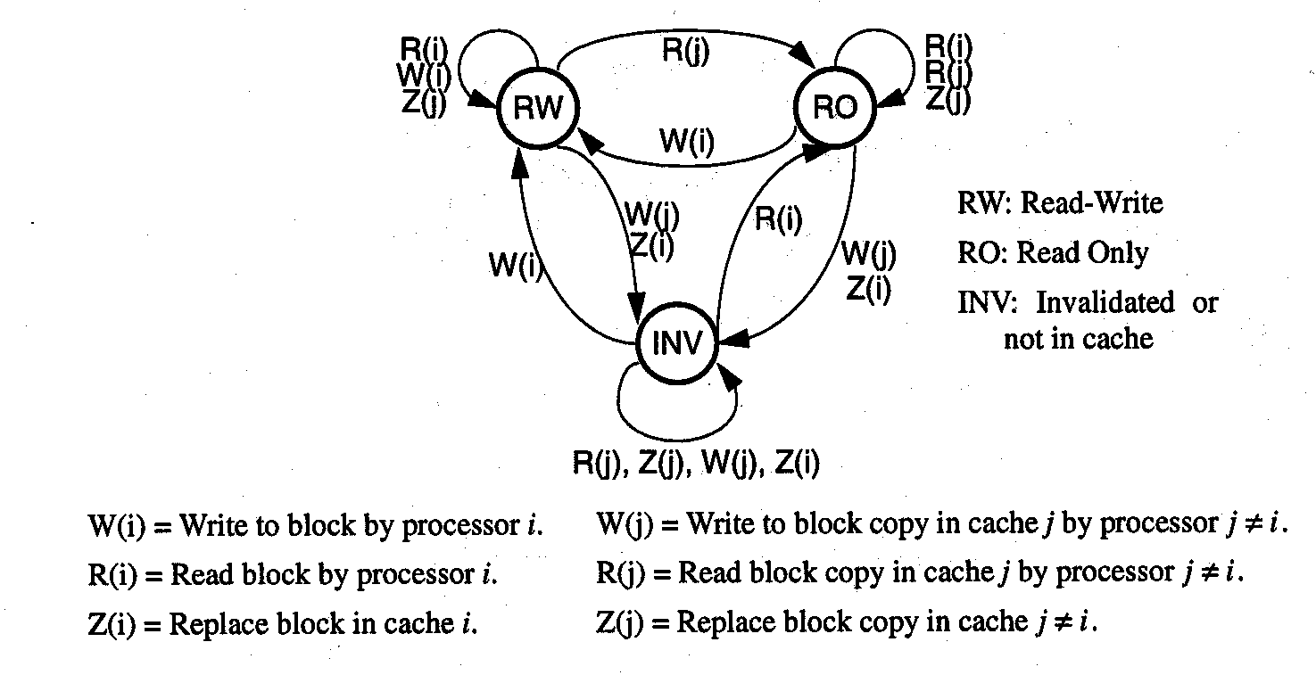

P1
Cycle | 0 | 1 | 2
Block 0  state | i
Block 0  Data | -
Block 1  State | i
Block 1  Data | -
Block 2  State | i
Block 2  Data | -
Block 3  state | i
Block 3  Data | -
Cache miss | -
Bus in use | -
i – invalid, M – modified, E - exclusive
P2
Cycle | 0 | 1 | 2
Block 0  state | i
Block 0  Data | -
Block 1  State | i
Block 1  Data | -
Block 2  State | i
Block 2  Data | -
Block 3  state | i
Block 3  Data | -
Cache miss
Bus in use

Question 5 (15)

Total time for implementation of the program on sequential processor is T(1)=1ms. The program is modified so that it can be executed on multiprocessing system with n=10 processors. Parallelism profile is shown in the figure bellow. Assume that there is no overhead due to communication and synchronization. Find the speedup and efficiency of this parallel system in comparison with the sequential one.

